Cote d’Ivoire

## Respect for rule of law (ROL) data

The data set shows the data on the respect of the rule of law for the country.

## # A tibble: 19 x 5  
## country iso3c date ruleOfLaw ruleOfLawCategory4   
## <chr> <chr> <dbl> <dbl> <chr>   
## 1 Cote d'Ivoire CIV 1996 -0.785 ROL moderately disrespected  
## 2 Cote d'Ivoire CIV 1998 -0.880 ROL moderately disrespected  
## 3 Cote d'Ivoire CIV 2000 -1.18 ROL highly disrespected   
## 4 Cote d'Ivoire CIV 2002 -1.30 ROL highly disrespected   
## 5 Cote d'Ivoire CIV 2003 -1.37 ROL highly disrespected   
## 6 Cote d'Ivoire CIV 2004 -1.37 ROL highly disrespected   
## 7 Cote d'Ivoire CIV 2005 -1.48 ROL highly disrespected   
## 8 Cote d'Ivoire CIV 2006 -1.45 ROL highly disrespected   
## 9 Cote d'Ivoire CIV 2007 -1.46 ROL highly disrespected   
## 10 Cote d'Ivoire CIV 2008 -1.42 ROL highly disrespected   
## 11 Cote d'Ivoire CIV 2009 -1.23 ROL highly disrespected   
## 12 Cote d'Ivoire CIV 2010 -1.22 ROL highly disrespected   
## 13 Cote d'Ivoire CIV 2011 -1.27 ROL highly disrespected   
## 14 Cote d'Ivoire CIV 2012 -1.08 ROL highly disrespected   
## 15 Cote d'Ivoire CIV 2013 -0.905 ROL moderately disrespected  
## 16 Cote d'Ivoire CIV 2014 -0.591 ROL moderately disrespected  
## 17 Cote d'Ivoire CIV 2015 -0.629 ROL moderately disrespected  
## 18 Cote d'Ivoire CIV 2016 -0.645 ROL moderately disrespected  
## 19 Cote d'Ivoire CIV 2017 -0.631 ROL moderately disrespected

## Respect for rule of law (ROL) trend

The plot shows the trend of the respect for the rule of law for the country.

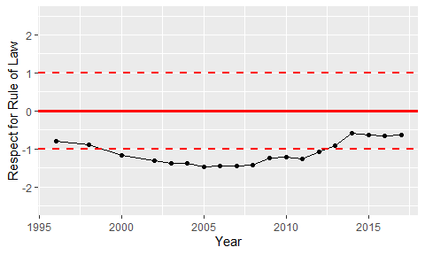

Trend of the Respect for the Rule of Law